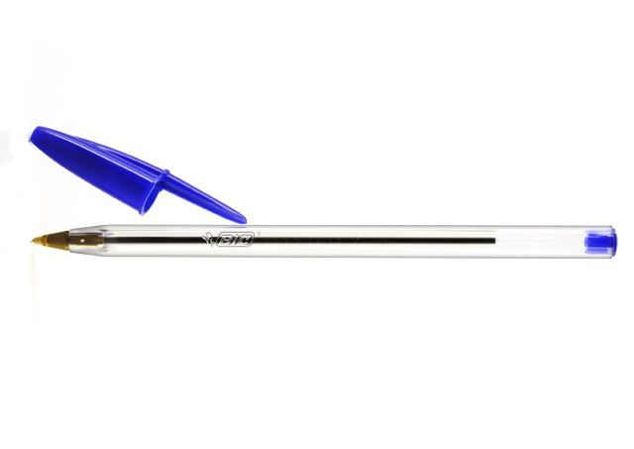
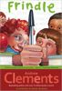
Name:_____________________________________ Date:__________________________

Frindle, by Andrew Clements

1. Describing his novel, Andrew Clements writes that Frindle "is about discovering the true nature of words, language, thought, community, learning." Take each of these ideas one at a time. How is each explored in Frindle? What do you think is the true nature of each?

2. The frindle is just one of Nick's great ideas. Brainstorm about ways you could improve your own school. How can you turn your ideas into action?

3. "Every good story," Mrs. Granger writes to Nick, "needs a bad guy, don't you think?" Do you agree? Does every good story have a villain? Can you think of any that don't?

4. Brian Selznick's illustrations add their own sly humor to Frindle. Discuss a few of your favorites in detail. For example, how does his first illustration, opposite the title page, help set up the novel? How do you know from his fullpage portrait of Mrs. Granger that she can't be pushed around?

5. Although Nick didn't know it until he turned twenty-one, his new word earned him a huge amount of money. Do you think his parents were right in setting up a trust fund for him? What do you think he might have done with the money if he could have spent it earlier? What would you do if you suddenly had a lot of money of your own?

6. "School," the author writes in Frindle, "was the perfect place to launch a new word." Why? What makes schools such good breeding grounds for fads? Do companies or community organizations ever use your school for promoting products or services? How?

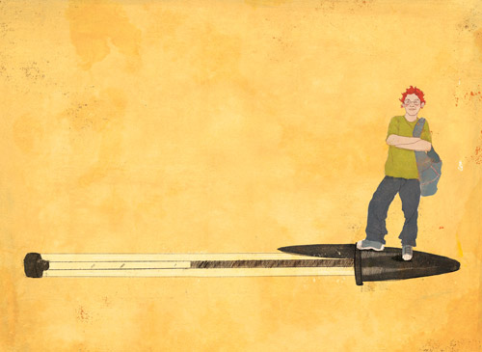
7. Years after he leaves Mrs. Granger's class, Nick finds a perfect way to show her how important she was to him. What's your teacher's idea of a perfect gift from a former student? Has he or she received it yet?

- See more at: http://books.simonandschuster.com/Frindle/Andrew-Clements/9780689806698/reading_group_guide#sthash.Xkf07mWD.dpuf

